**CURRICULUM VITAE**

**Ms. Katerina Stavreska**

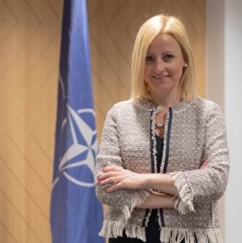**Katerina Stavreska** is NATO and Security Policy Director in the Ministry of Foreign Affairs of North Macedonia.

Before assuming her current position in 2021, Ms. Stavreska served for three years as a Chief Foreign Policy Advisor and Chief of the Cabinet of the former Deputy Prime Minister and Minister of Defence Radmila Shekerinska.

During this time Ms. Stavreska also assumed the duty of State Advisor for NATO and EU in the Ministry of Defence and in her capacity, she held the primary responsibility for coordination of the final phase of the integration of North Macedonia to NATO. In addition she was a Coordinator for implementation of Gender perspective to the MoD and the Armed Forces and led the process of the development of the second national NAP for implementation of UNSCR 1325. .

Prior to joining MoD Ms. Stavreska served in the MFA as a career diplomat, starting in 2006. Among other she was Head of the NATO Unit responsible for the implementation of National Membership Action Plan; member of the National team for EU Visa Liberalization and a member to the MFA Diplomatic Bulletin Editorial Board.

Ms Stavreska is a graduate in political studies from the University of St. Cyril and Methodius where she obtained also an MBA. She is a PG from the King’s College London and a Member of the UK Royal College of Defence Studies.

She has a large portfolio of international trainings and strategic policy courses including Managing Defense in the Wider Security Context and Senior Strategic Leadership Programme of the UK Defence Academy, the First international security course on the Balkans organized by the French Institute of Advanced Studies in National Defence (l’ Institut des hautes études de defense nationale IHEDN) and 15th CSDP High Level Course “ALTIERO SPINELLI”.

Ms. Stavreska is also an Alumni of the US State Department International Visitors Leadership Program (on U.S. – European Security Issues) and an honorary citizen of the US Great State of Nebraska.